AI-Driven Networking

As we learned in this class, traditional network management methods may no longer meet the needs of modern enterprises with the rapid growth of network complexity and data traffic. And because artificial intelligence is a hot topic right now, I am interested by the combination of artificial intelligence and the internet management, which is called Artificial Intelligence for IT Operations (AIOps).

Artificial Intelligence for IT Operations (AIOps) is a practice that uses artificial intelligence and machine learning to enhance and automate various aspects of IT operations such as improving network automation management, performance optimization, and fault detection capabilities. It aims to streamline workflows, predict potential issues, automate incident response, and ultimately improve the performance and efficiency of enterprise environments. [1]

AIOps is related to most levels of the computer network model we learned in the course. Primarily, we monitor, configure and manage network in network layer. By using it, we can improve network performance through intelligence management of network services. We can make networks self-adjusting their coverage and capacity where and when it’s needed. Networks can even heal themselves when things go wrong, and optimize for superior performance and service delivery all of the time with no intervention from human. It can also Adjust routing strategies, traffic engineering and so on. What’s more, we control the transmission of data in the network and link in the link layer, and we can analyze link performance data to identify bottlenecks and failures by utilizing AIOps. When problems occur in the transmission of data, we can gain some excellent solutions or technologies timely from AI or machine learning (ML) models.

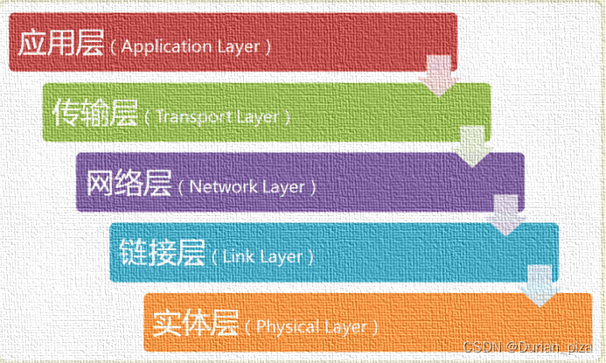

Automation is the current focus of operators and artificial intelligence is the popular trend, so the combination of these two is attracting much attention. Most network automation functions still use traditional methods to improve performance. As we can see that traditional algorithms are gradually being enhanced or replaced by artificial intelligence algorithms that can adapt to different wireless conditions and environments and reused throughout the network. With the large-scale deployment of 5G around the world, new application scenarios continue to emerge, such as the Internet of Things. It’s obvious that AI-driven is important to the future success of network. However, achieving comprehensive network infrastructure automation and optimization requires powerful capabilities, making AI and ML more important than ever.

According to the research, there are three ways to integrate AI into network components: replacing existing algorithms or components with AI-driven algorithms or components; adding new AI components with new capabilities on top of existing base components or adding AI-based controls to existing traditional components.

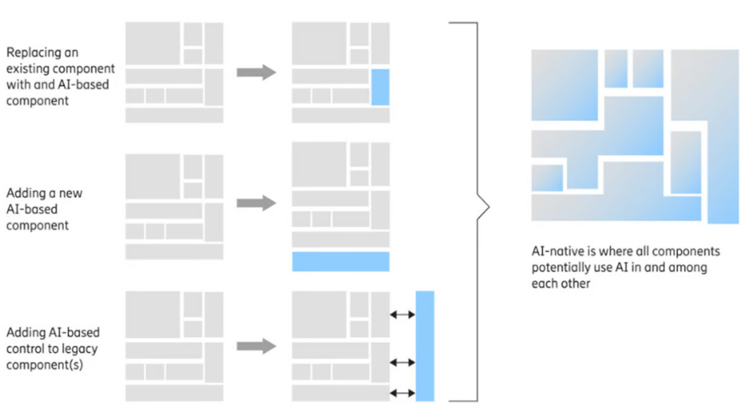

AI can optimize IT operations in five ways. First of all, we use AI to monitor the network intelligently, which helps to avoid unnecessary terminals or congestion problems, and optimize indicators such as average detection time. Secondly, AI can help make decisions faster by reading and analyzing large data sets timely. Third, AI-driven automated infrastructure optimization efficiently allocates resources and reduces cloud costs. Fourth, enhanced IT service management reduces critical incidents by over 50% through AI-driven end-to-end service management. Lastly, intelligent task automation accelerates problem resolution and automates remedial actions with minimal human intervention.[2]

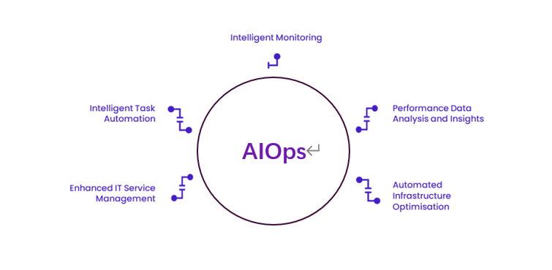

In contrast to MLOps (Machine Learning Operations), which focuses on the lifecycle management and operational aspects of machine learning models, AIOps focuses on optimizing IT operations using a variety of analytics and AI-driven techniques. While both disciplines rely on AI and data-driven methods, AIOps primarily targets IT operations, whereas MLOps is concerned with the deployment, monitoring, and maintenance of ML models.[3]

Continuous learning is the base of AIOps, enabling the system to learn from past experiences and adapt to new challenges, driving continuous improvement in IT operations. This dynamic capability ensures that AIOps platforms remain effective in the face of changing IT environments and emerging threats. Continuous learning also plays an important role in predictive maintenance. By analyzing historical data and identifying patterns before failures occur, AIOps can predict when components are likely to fail and recommend preventive maintenance. This proactive approach can reduce downtime and extend the life of IT infrastructure.

AI-driven network is still facing some challenges. The decision-making process of AI and machine learning models is difficult for us to observe, and the decision results are difficult to explain. So we need a more reliable model or a visible analysis process. In addition, AIOps needs to process large amounts of data in real time. In order to ensure lower latency and higher throughput, we need better facilities, which requires a significant investment in equipment performance and storage.

In the future, we will employ more advanced AI and ML models to improve anomaly detection and prediction capabilities, enabling AIOps to identify potential issues more accurately and provide more precise solutions. And as edge computing becomes more popular, AIOps will be able to process and analyze data on edge devices to support real-time decision making, which will reduce latency and improve application performance, especially in IoT and real-time application scenarios.

**References**

1. China, Chrystal R. (August 12, 2024). "AIOps vs. MLOps: Harnessing big data for "smarter" ITOPs". IBM. Retrieved August 19, 2024.
2. "AIOps: The Secret Engine Behind Next-Gen IT Performance". *Wavestone*. May 14, 2024. Retrieved August 19, 2024.
3. Maffeo, Lauren (February 25, 2021). "AIOps vs. MLOps: What's the difference? | Opensource.com". *OpenSource*. Retrieved August 19, 2024.